Navigating AwardSpring: A Guide for Donors
This guide walks you through accessing your account on the AwardSpring platform. Start by navigating to your organization’s AwardSpring site. Your organization’s administrator will provide the URL.

You'll land on the login page (this page is customizable, so your organization’s login page may look different from the example below). The administrator created your account, but you’ll need to set up your password—click Forgot Password to do so.

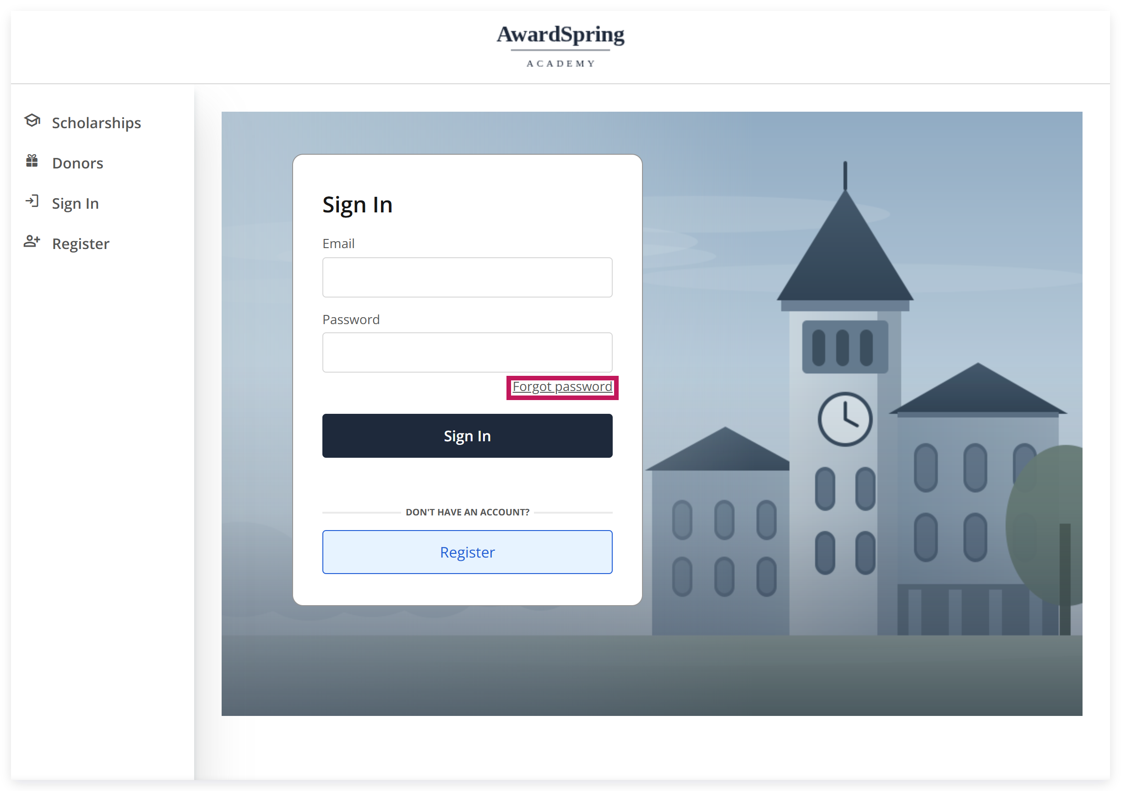

You’ll land on the password reset screen. Enter your email and click Reset Password.

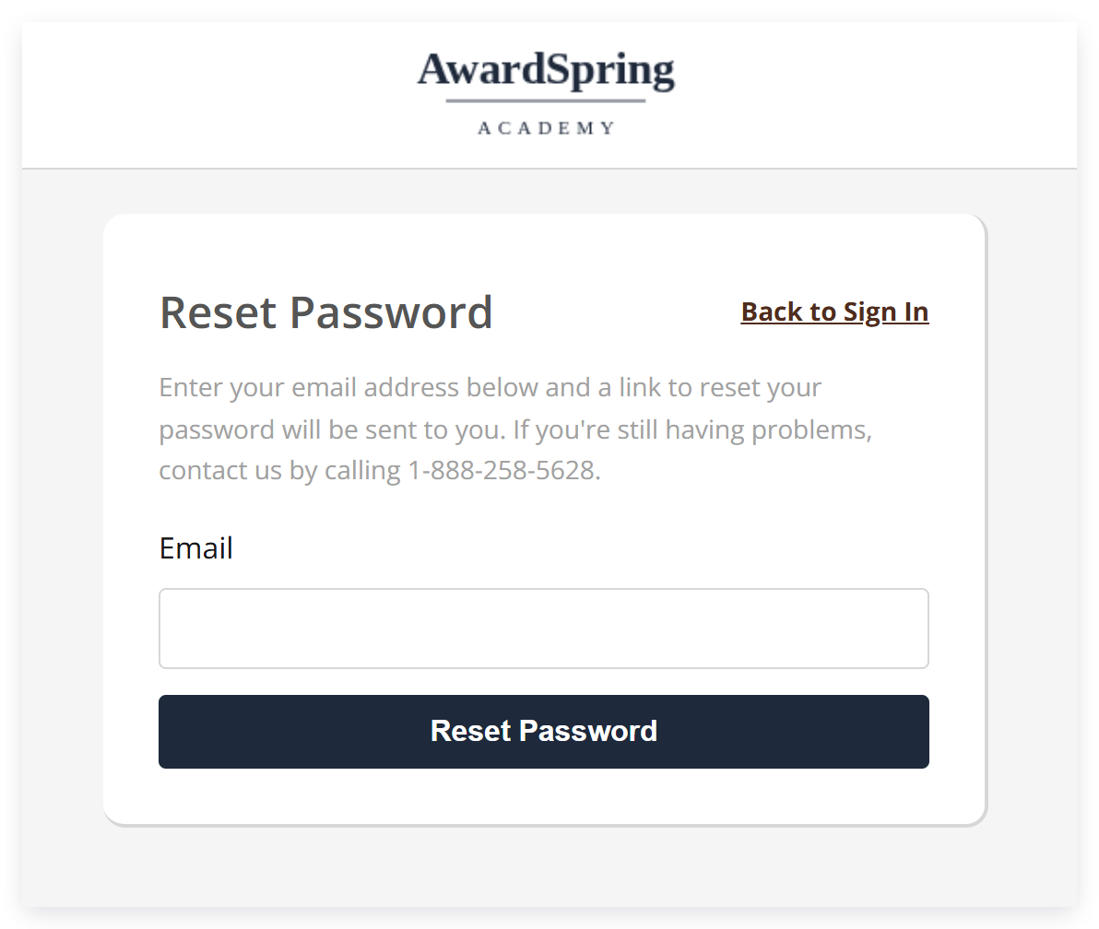

You’ll receive an email containing a link to reset your password. Click the link in the email (or the Reset Password button it contains) to open the password screen.

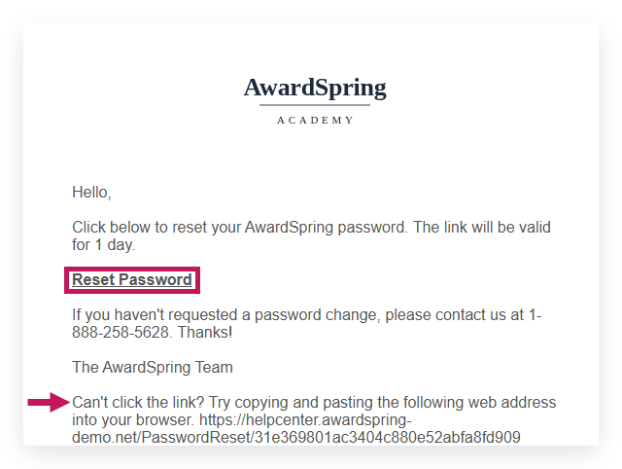
Type your new password twice, then click Reset Password.

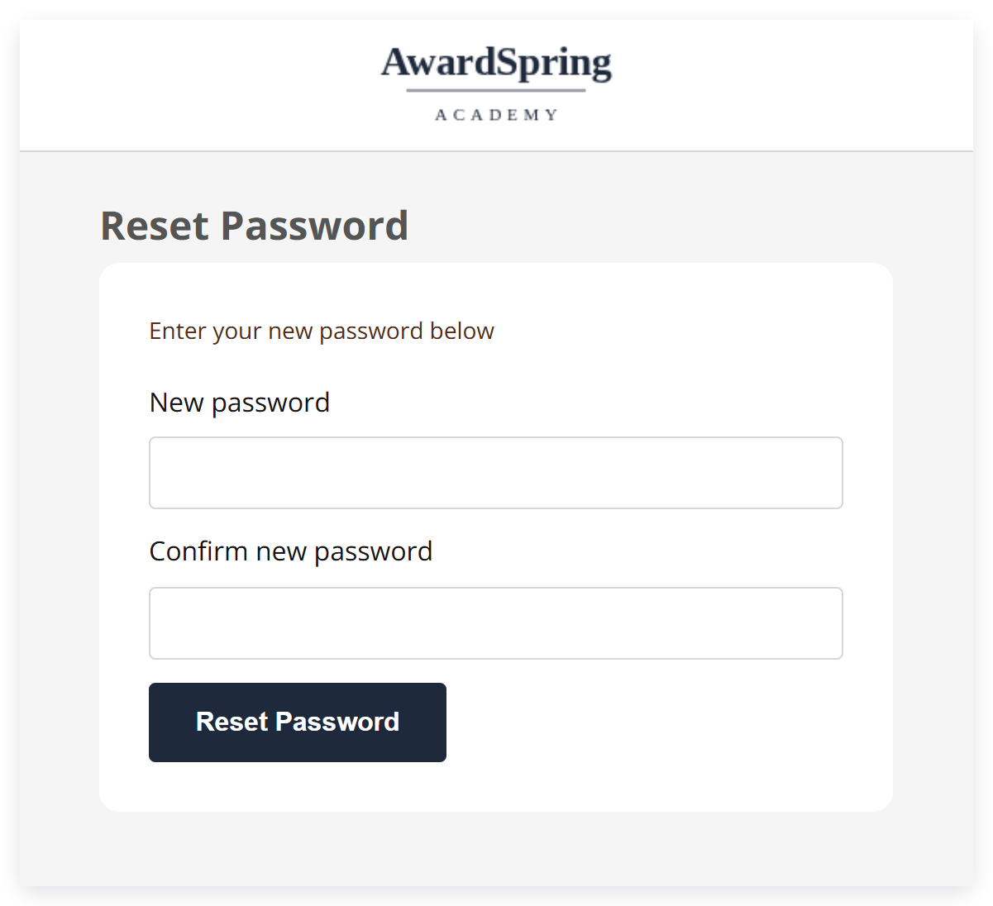

Next, you’ll be asked to agree to the terms of use and privacy policy. Check the box, then click Accept Agreement.

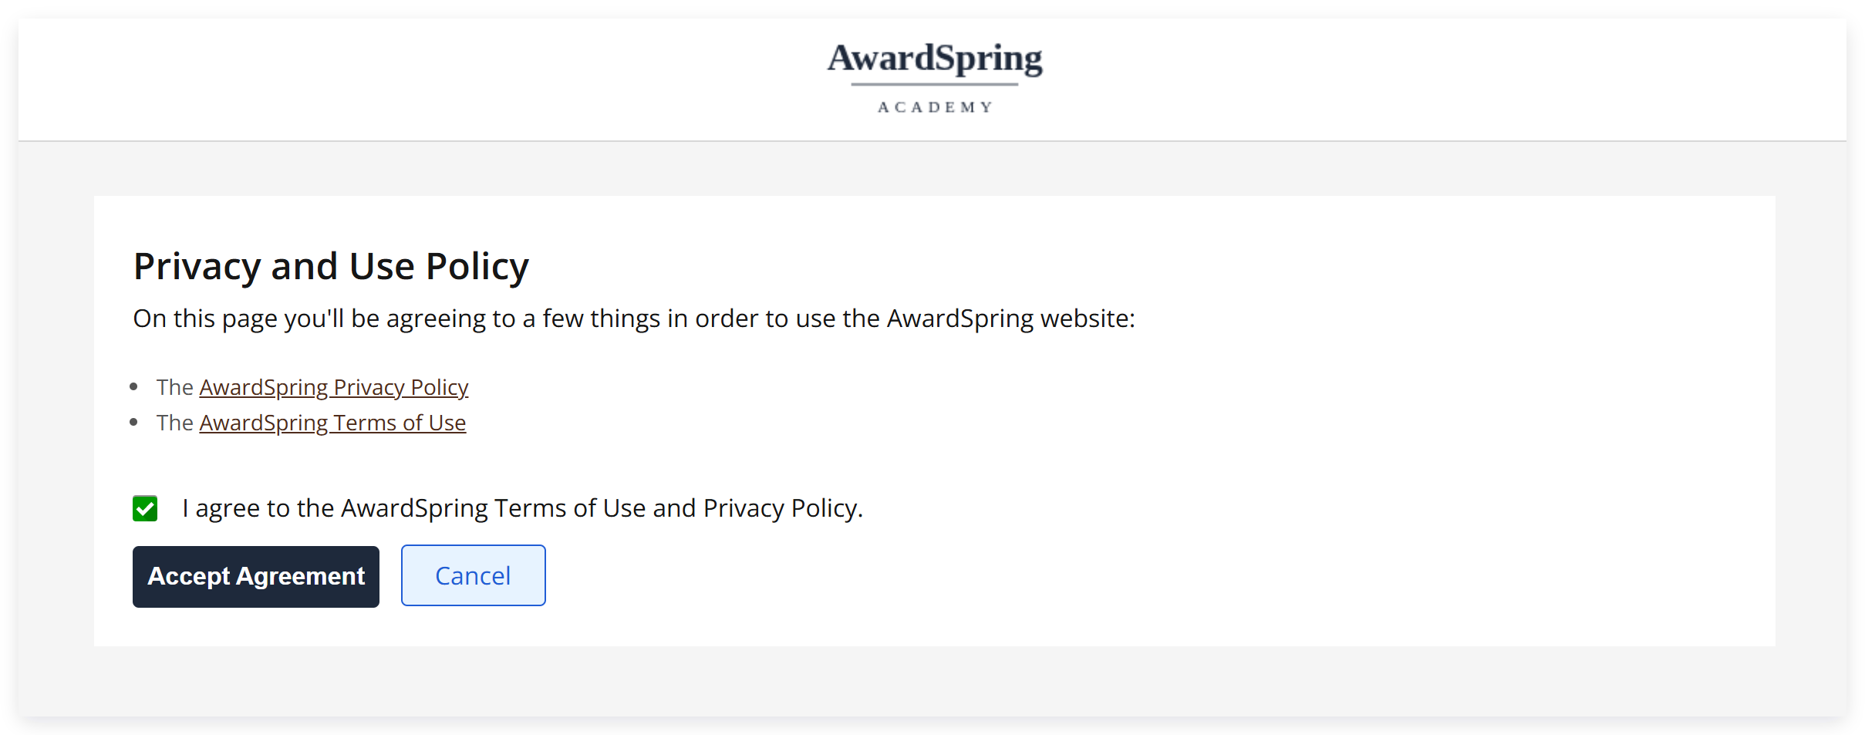

You’ll then land on your dashboard. Under the Applicants tab, you’ll find a list of applicants for the scholarships you are associated with.

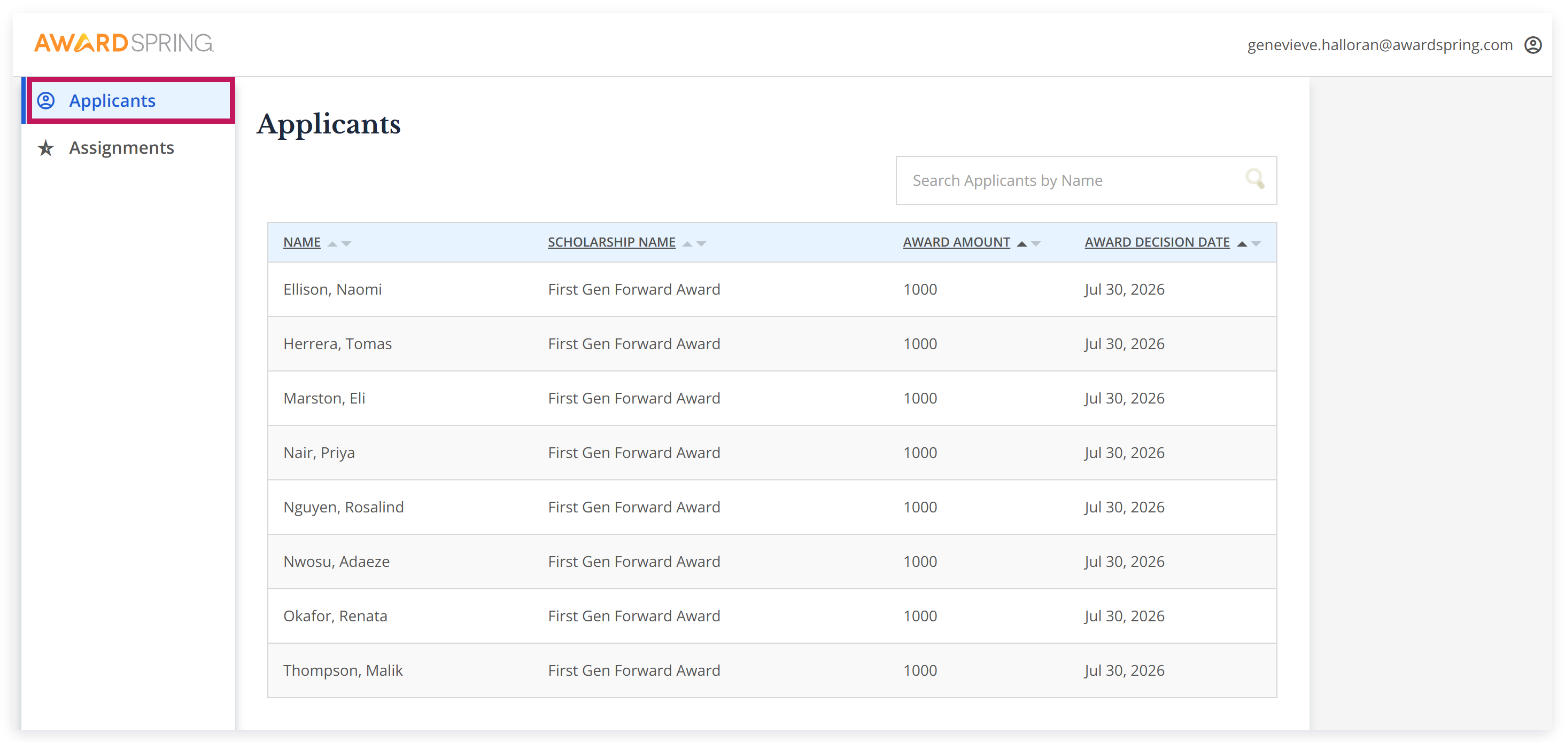

Select an applicant’s name to view their application responses.

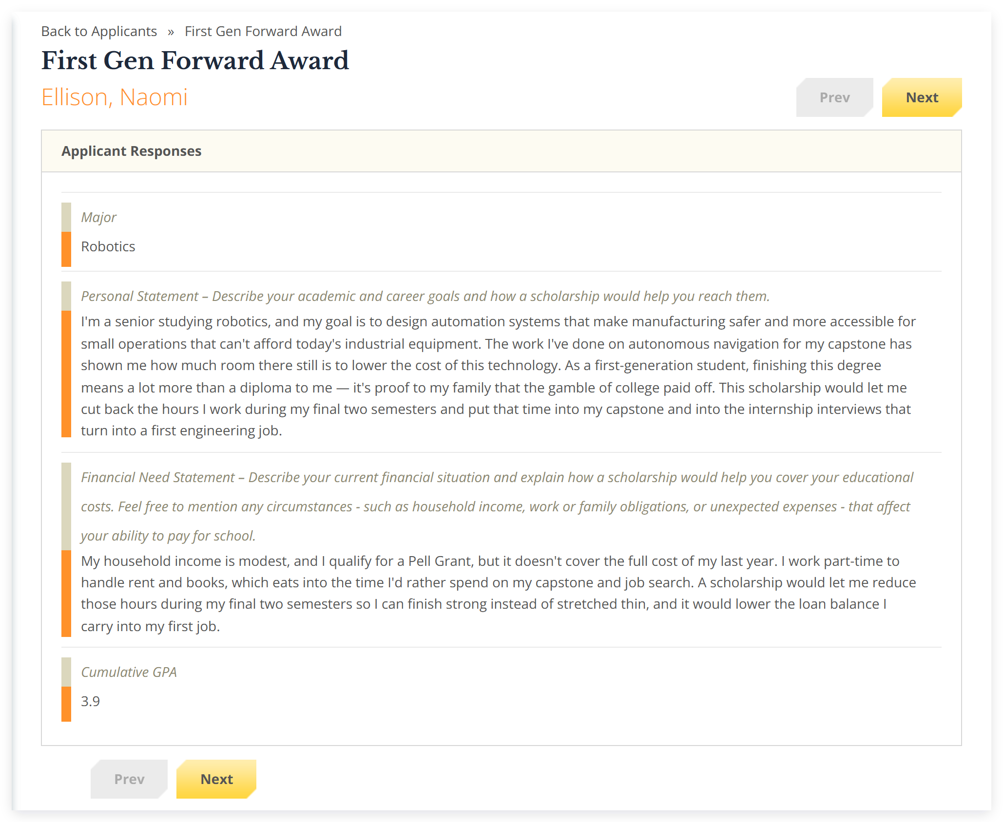

If you’re reviewing/scoring applicants, you’ll be able to complete this task under the Assignments tab, which lists the review groups you were assigned to and the applicants remaining in each—select a review group to see the list of applicants assigned to you within it.

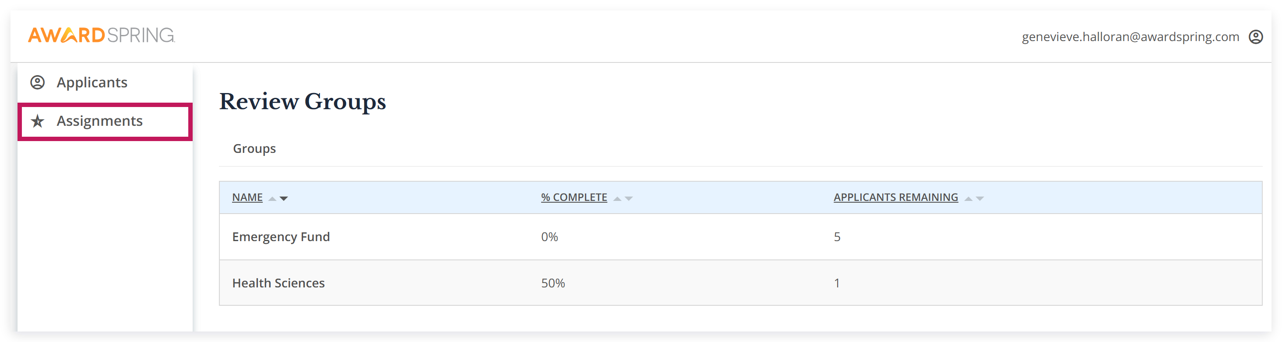

Once you select an applicant, you can view their application, score them under the Score Cards tab, and leave a comment (optional).

Note: If the applicant names have been blinded, you will see a number populated instead of their name

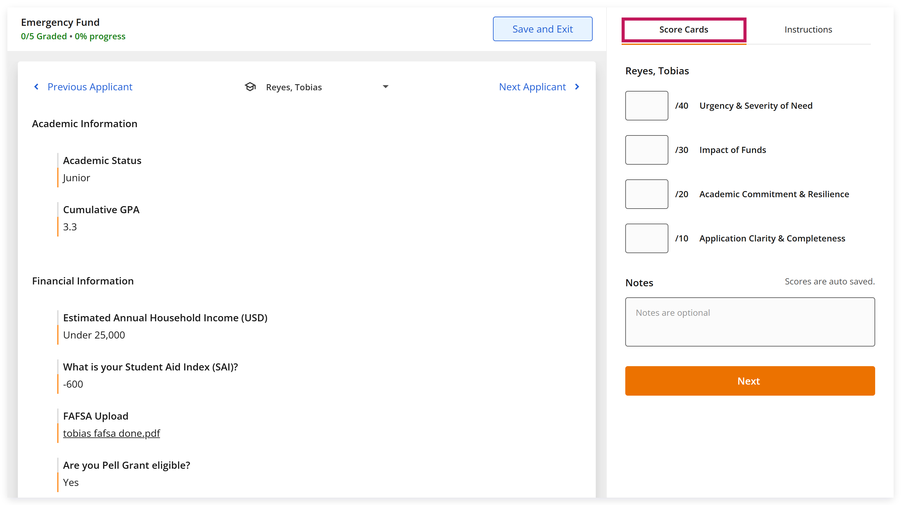

Under the Instructions tab, you’ll have access to scoring instructions provided by the scholarship administration team.

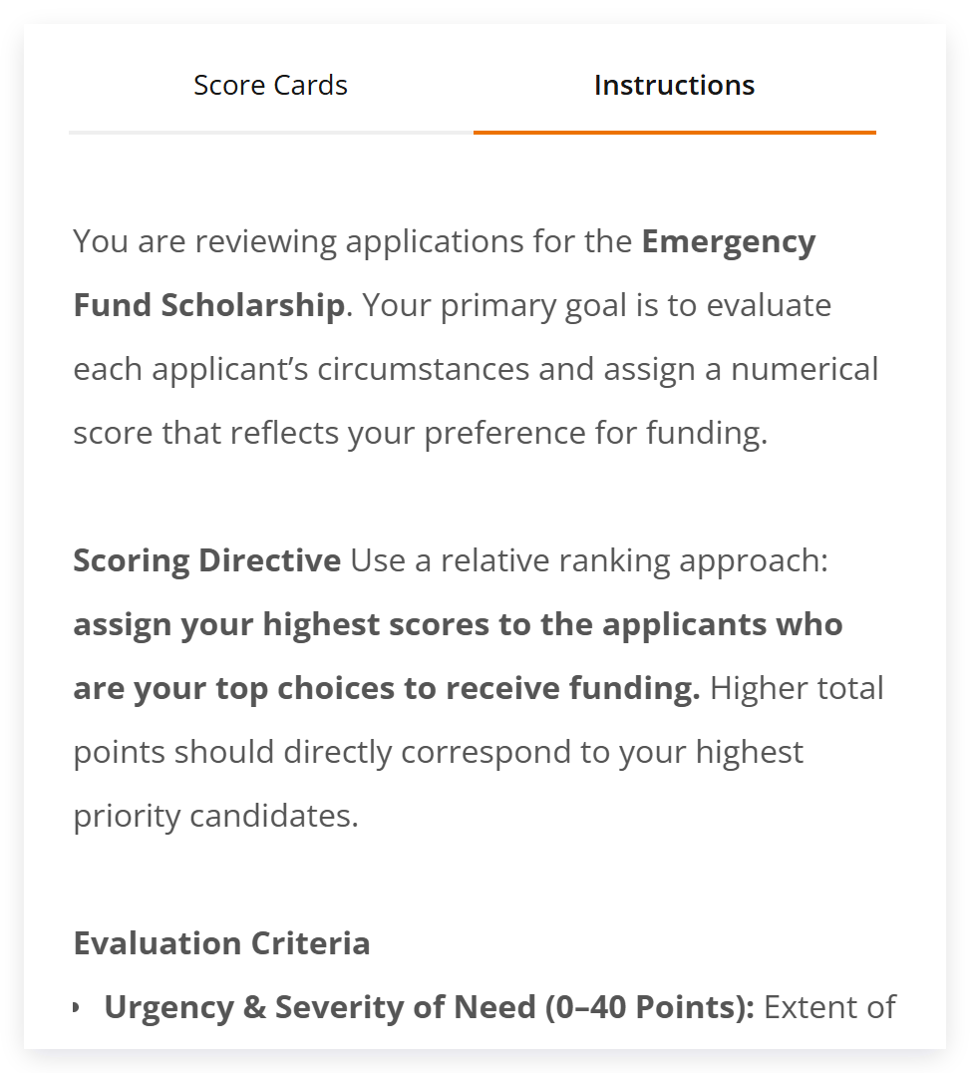

Once done, click the Next Applicant button to review the next applicant.

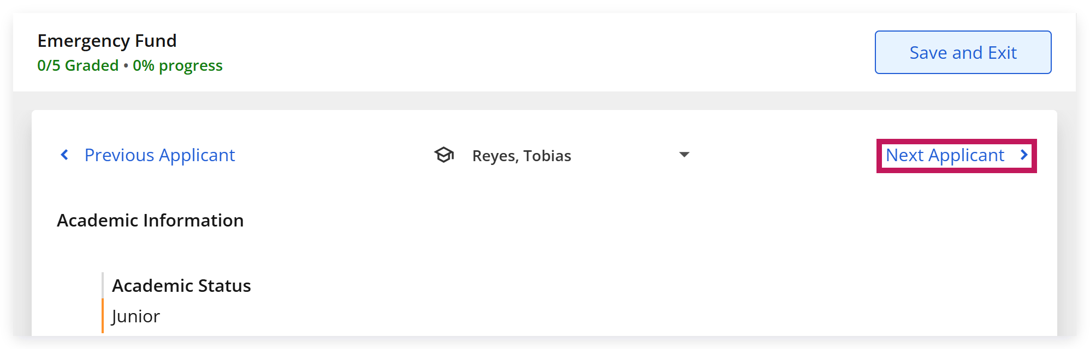

After you've scored all applicants, click the Save and Exit button.

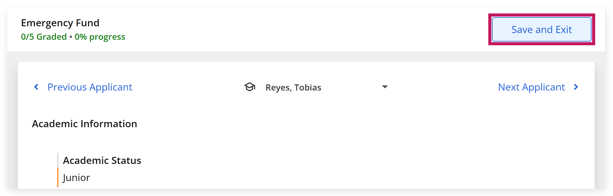

Otherwise, you can sign out of your account by clicking the profile icon in the top right corner, then clicking Log Out.

